This document contains videos.

When exporting the videos didn’t stay videos and turned into pictures instead so we have put the video title in text in red under under the video / image that is supposed to be that video and you can find it inside the GitHub in the evidencing folder with the same name. The description to go along with the video is then underneath.

**Testing using the Arduino**

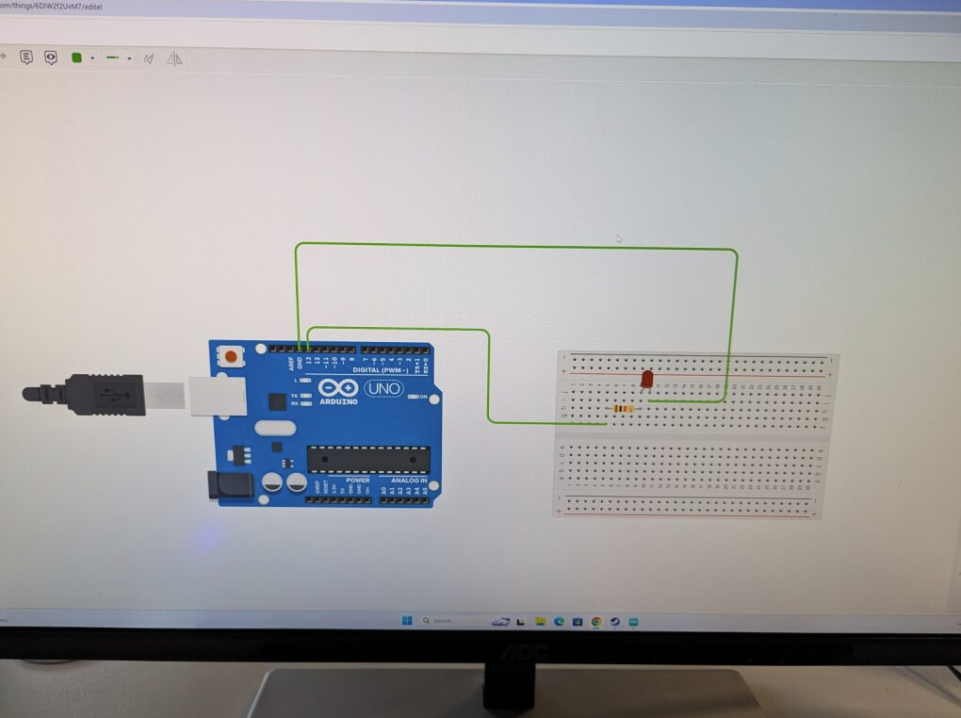

[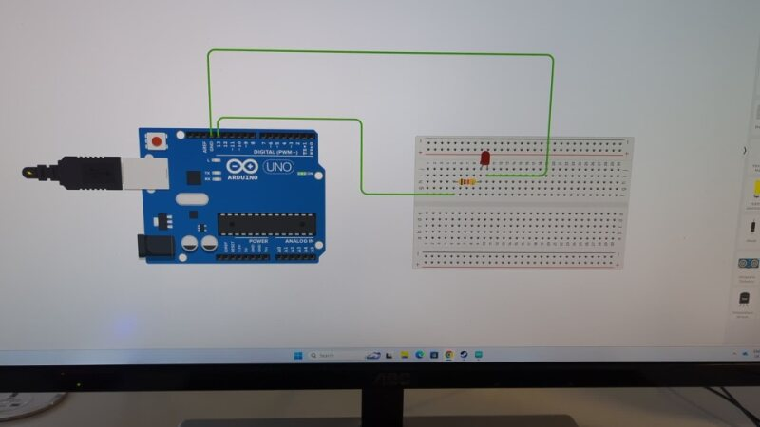](https://bathspaonline-my.sharepoint.com/:v:/r/personal/fred_burdekin22_bathspa_ac_uk/Documents/Tangible%20games/Arduino%20Game%20Stuff/Testing%20arduino/TinkerCad%20Arduino%20Light%20Flashing%20Vid.mp4?csf=1&web=1&nav=eyJyZWZlcnJhbEluZm8iOnsicmVmZXJyYWxBcHAiOiJPbmVEcml2ZUZvckJ1c2luZXNzIiwicmVmZXJyYWxBcHBQbGF0Zm9ybSI6IldlYiIsInJlZmVycmFsTW9kZSI6InZpZXciLCJyZWZlcnJhbFZpZXciOiJNeUZpbGVzTGlua0NvcHkifX0&e=IeNjOv)

***VIDEO***

TinkerCad Arduino light flashing vid.mp4

I used Tinker Cad to create a circuit with some code to make the light that has been attached to the breadboard to flash.

[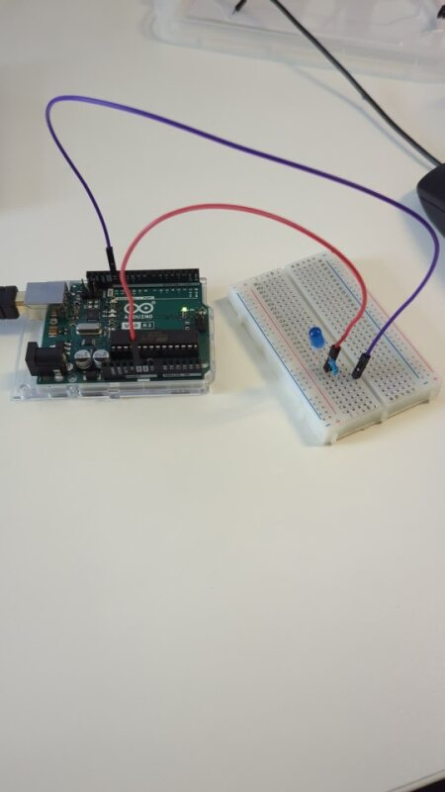](https://bathspaonline-my.sharepoint.com/:v:/r/personal/fred_burdekin22_bathspa_ac_uk/Documents/Tangible%20games/Arduino%20Game%20Stuff/Testing%20arduino/Arduino%20Light%20Flashing.mp4?csf=1&web=1&nav=eyJyZWZlcnJhbEluZm8iOnsicmVmZXJyYWxBcHAiOiJPbmVEcml2ZUZvckJ1c2luZXNzIiwicmVmZXJyYWxBcHBQbGF0Zm9ybSI6IldlYiIsInJlZmVycmFsTW9kZSI6InZpZXciLCJyZWZlcnJhbFZpZXciOiJNeUZpbGVzTGlua0NvcHkifX0&e=Jb9di6)

***VIDEO***

Arduino Light Flashing.mp4

I recreated the flashing light setup on actual hardware and wired it up.

**Our Tangible Games Game Idea**

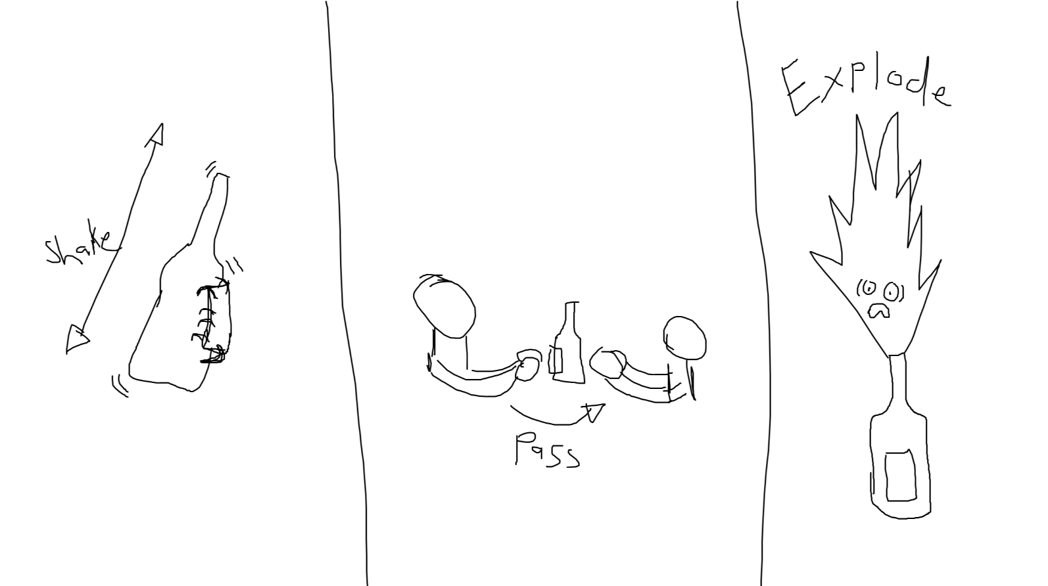

Our game idea is similar to hot potato where the players pass around a bottle which they shake it as much or as little as they want and then pass it to the next player. However, each time a player shakes the bottle, there is a chance that it could “fizz up” and “explode” which then means that player is out and then the game resets and continues until only one player remains standing.

To achieve this, we knew we needed to use an accelerometer so we started looking into the BNO055, we looked through the different examples within the IDE libraries, as well as glances at the documentation for any other information we may need

Documentation for BNO055: https://cdn-learn.adafruit.com/downloads/pdf/adafruit-bno055-absolute-orientation-sensor.pdf

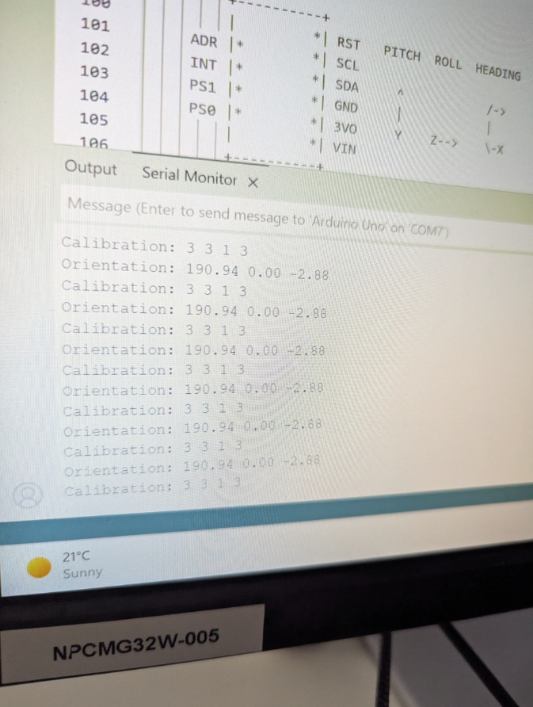

We attached the BNO055 to the Arduino and got some code from the BNO055 documentation to learn how we can incorporate the hardware and code into the development of our shake the bottle game.

This code outputted to us the calibration and orientation of the device.

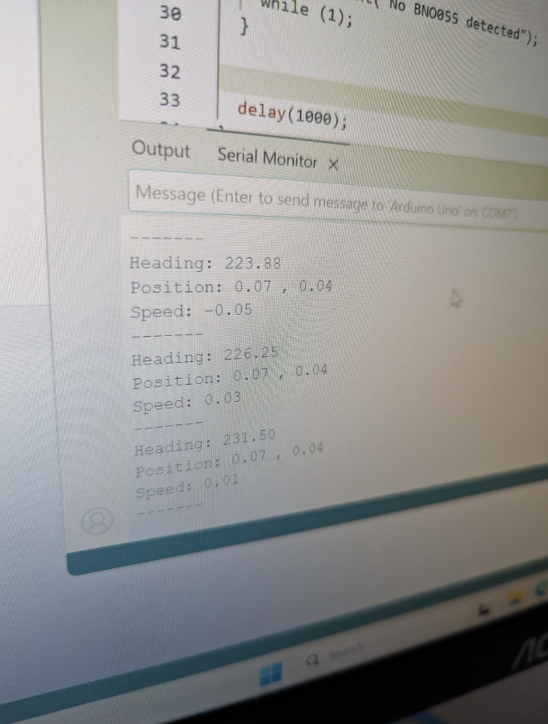

We used the BNO055 documentation to get code again, but this code outputted the devices heading, position and speed. This documentation code is what we will use and adapt it into our own code and to detect when the player shakes the bottle.

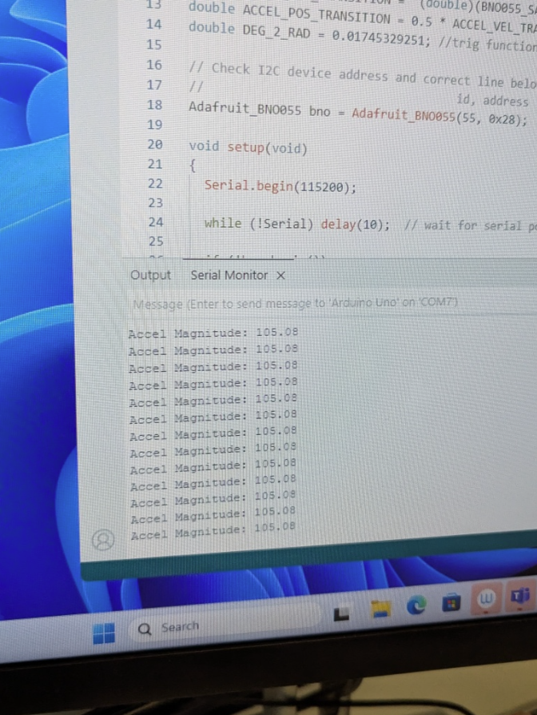

We got the accelerometer attached to the Arduino with some code that gives us the accel magnitude, but we want to change this into detecting shakes through converting the accel magnitude into speed and then detecting spikes in that speed to count as a shake.

[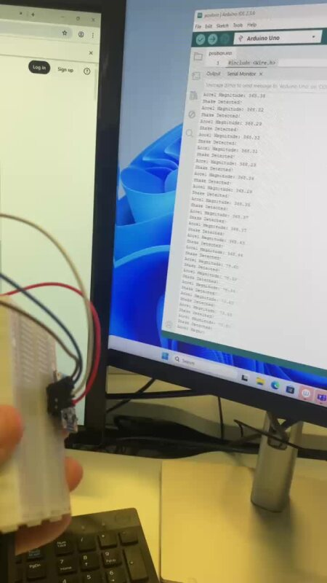](https://bathspaonline-my.sharepoint.com/:v:/r/personal/fred_burdekin22_bathspa_ac_uk/Documents/Tangible%20games/Arduino%20Game%20Stuff/Documentation%20Pics/Shakes%20detecting%20all%20the%20time.mov?csf=1&web=1&nav=eyJyZWZlcnJhbEluZm8iOnsicmVmZXJyYWxBcHAiOiJPbmVEcml2ZUZvckJ1c2luZXNzIiwicmVmZXJyYWxBcHBQbGF0Zm9ybSI6IldlYiIsInJlZmVycmFsTW9kZSI6InZpZXciLCJyZWZlcnJhbFZpZXciOiJNeUZpbGVzTGlua0NvcHkifX0&e=vusfuK)

***VIDEO***

Shakes detecting all the time.mov

We have gotten shake detection implemented by adding Stability_Time and is_Shaking checks to the code. The way we coded in the shake detection is with a threshold being compared to the magnitude and acceleration.

As well as having the threshold that has to be met to count as a shake, we also added in stabilisation time in the code so that the program is not constantly outputting a shake and making the counter go up if the requirements are met which we solved with this “cooldown”.

The Arduino however is constantly detecting shakes even if it's not moving so we have got to tweak the threshold to get it to a sensitivity level that we want for our game.

Ultimately, the way we handle detection was through finding the total magnitude of acceleration each shake using 3D Pythagoras on the 3 vectors for X, Y and Z, using this we would apply the threshold above so we could adjust the sensitivity of the system. And finally adding a stability time so 2 consecutive shakes are detected, as originally, we had multiple issues of shakes being detected 3-4 times each shake without a stability time. Furthermore, the threshold allowed us to move the game around and pass it from player to player without shakes being detected.

[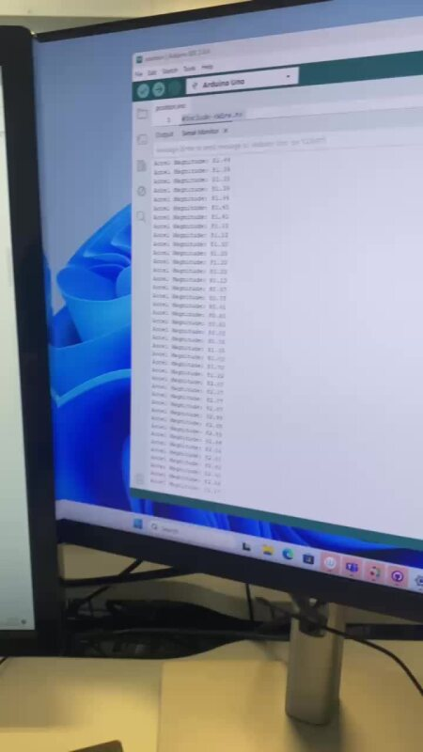](https://bathspaonline-my.sharepoint.com/:v:/r/personal/fred_burdekin22_bathspa_ac_uk/Documents/Tangible%20games/Arduino%20Game%20Stuff/Documentation%20Pics/Detects%20shake%20still%20too%20easily.mov?csf=1&web=1&nav=eyJyZWZlcnJhbEluZm8iOnsicmVmZXJyYWxBcHAiOiJPbmVEcml2ZUZvckJ1c2luZXNzIiwicmVmZXJyYWxBcHBQbGF0Zm9ybSI6IldlYiIsInJlZmVycmFsTW9kZSI6InZpZXciLCJyZWZlcnJhbFZpZXciOiJNeUZpbGVzTGlua0NvcHkifX0&e=TQOms1)

***VIDEO***

Detects Shakes still too easy.mov

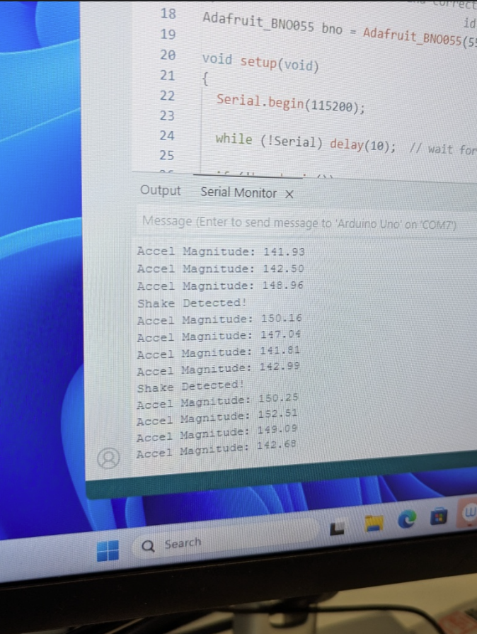

Got the shake detected code setup but it doesn't take much movement at all to detect one, so we need to increase the threshold for what is considered a “Shake” because right now just picking it up and slowly moving it around is flagged as a shake.

[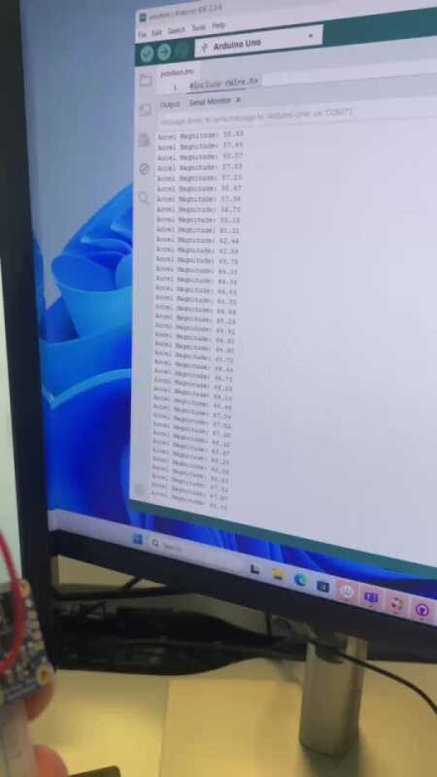](https://bathspaonline-my.sharepoint.com/:v:/r/personal/fred_burdekin22_bathspa_ac_uk/Documents/Tangible%20games/Arduino%20Game%20Stuff/Documentation%20Pics/Shakes%20Working%20more%20right.mov?csf=1&web=1&nav=eyJyZWZlcnJhbEluZm8iOnsicmVmZXJyYWxBcHAiOiJPbmVEcml2ZUZvckJ1c2luZXNzIiwicmVmZXJyYWxBcHBQbGF0Zm9ybSI6IldlYiIsInJlZmVycmFsTW9kZSI6InZpZXciLCJyZWZlcnJhbFZpZXciOiJNeUZpbGVzTGlua0NvcHkifX0&e=HjQiYk)

***VIDEO***

Shakes working more right.mov

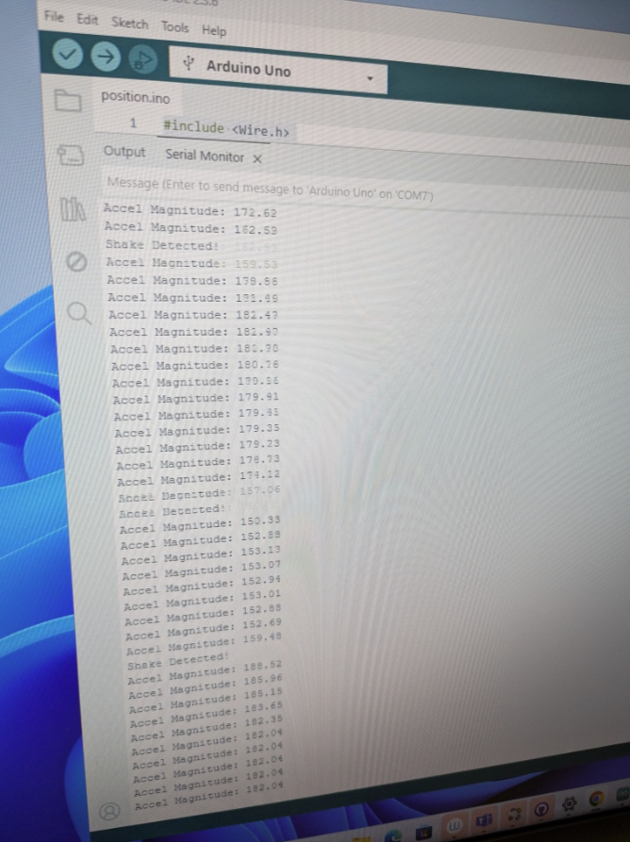

We have now increased the threshold to what can be considered a shake, so it isn't as easy to do as before. We are still tweaking the threshold to get it to a good sensitivity and level that we want for our game, but it is much better and more accurate than what it was previously.

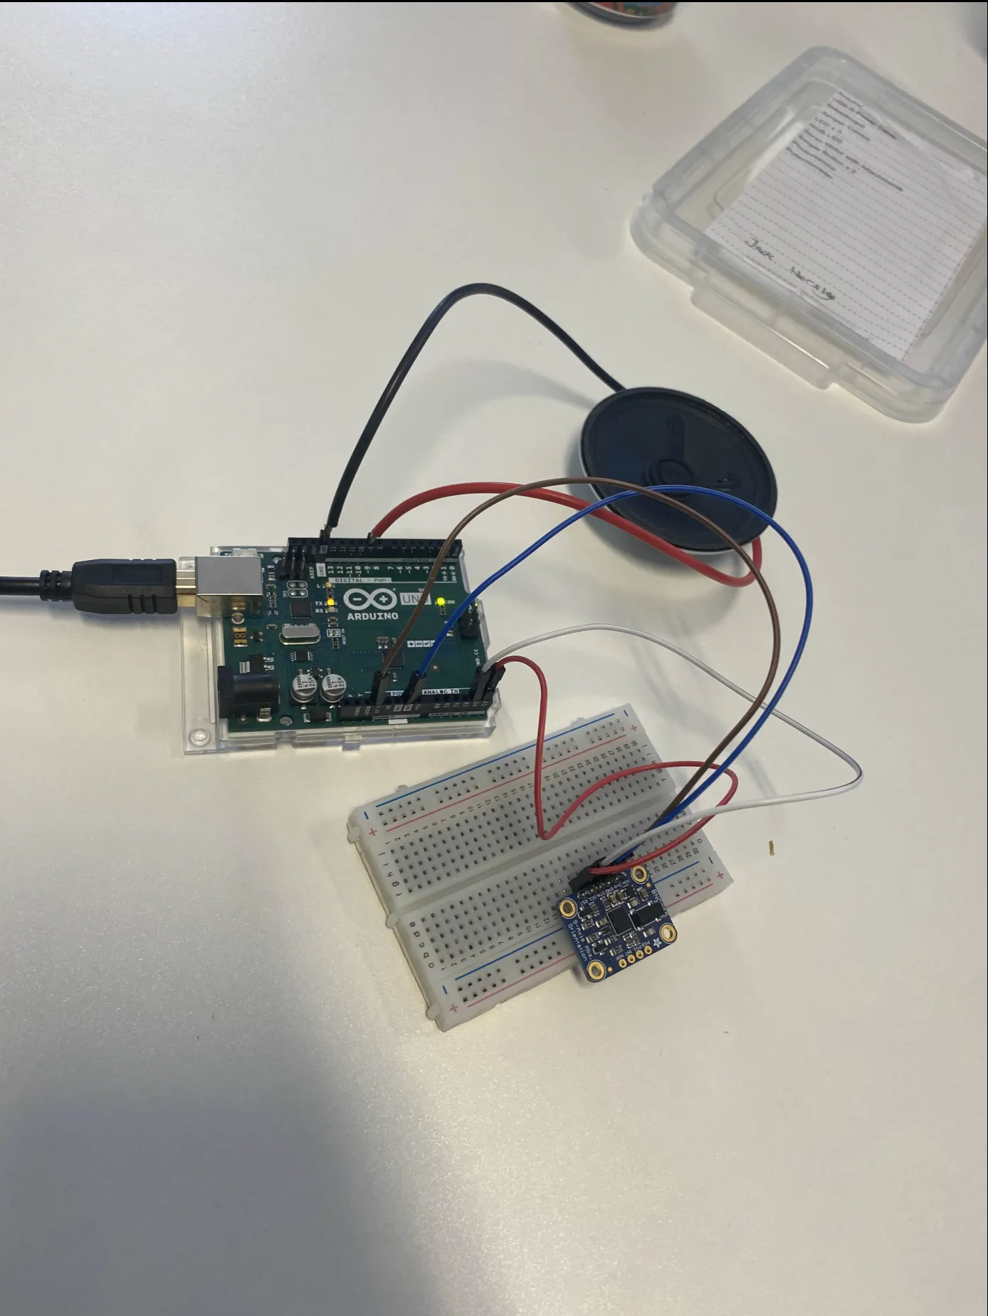

[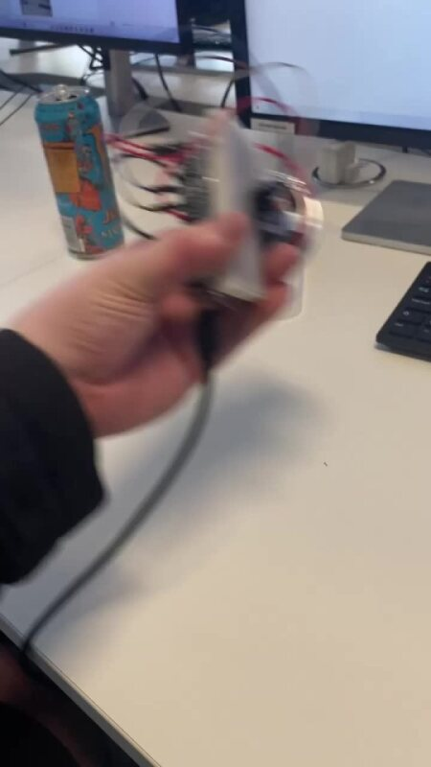](https://bathspaonline-my.sharepoint.com/:v:/r/personal/fred_burdekin22_bathspa_ac_uk/Documents/Tangible%20games/Arduino%20Game%20Stuff/Documentation%20Pics/Video%20Speaker%20Attached.mov?csf=1&web=1&nav=eyJyZWZlcnJhbEluZm8iOnsicmVmZXJyYWxBcHAiOiJPbmVEcml2ZUZvckJ1c2luZXNzIiwicmVmZXJyYWxBcHBQbGF0Zm9ybSI6IldlYiIsInJlZmVycmFsTW9kZSI6InZpZXciLCJyZWZlcnJhbFZpZXciOiJNeUZpbGVzTGlua0NvcHkifX0&e=eBCkSP)

***VIDEO***

Video speaker attached.mov

We attached a speaker to play beeps for every time a shake is detected as well as beeping lots when the “bottle is exploding” and that player is out / end of the game.

[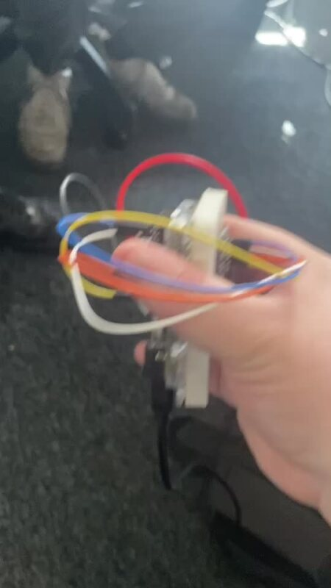](https://bathspaonline-my.sharepoint.com/:v:/r/personal/fred_burdekin22_bathspa_ac_uk/Documents/Tangible%20games/Arduino%20Game%20Stuff/Documentation%20Pics/Double%20Beep.mp4?csf=1&web=1&nav=eyJyZWZlcnJhbEluZm8iOnsicmVmZXJyYWxBcHAiOiJPbmVEcml2ZUZvckJ1c2luZXNzIiwicmVmZXJyYWxBcHBQbGF0Zm9ybSI6IldlYiIsInJlZmVycmFsTW9kZSI6InZpZXciLCJyZWZlcnJhbFZpZXciOiJNeUZpbGVzTGlua0NvcHkifX0&e=c1nAxY)

***VIDEO***

Double beep.mp4

We decided to add a second beep that plays when the game is about 75 percent of the way through and close to “exploding”. We decided on this feature as otherwise the players wouldn't have any sort of indication on how close the bottle was from “exploding”. This second beep is supposed to tell the people playing that they should be more cautious with the amount that they shake the bottle if they don't want to be the one to explode. This indicator can add strategy to how the game is played with mind games, trying to set it up for the next player etc.

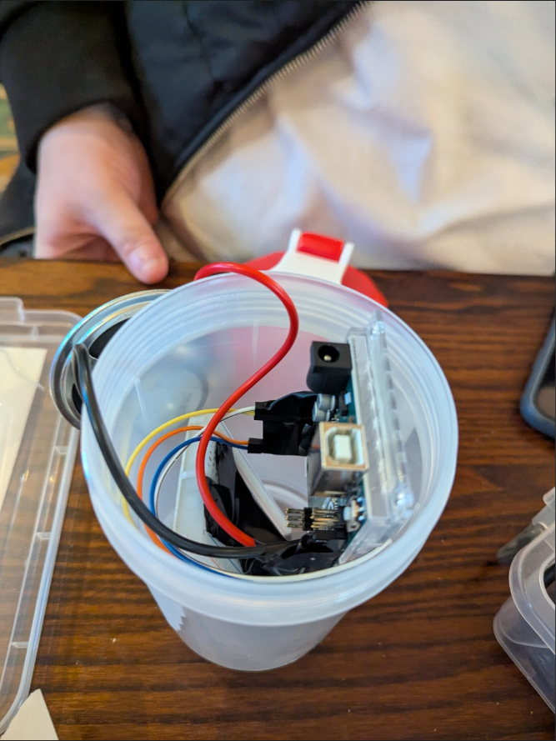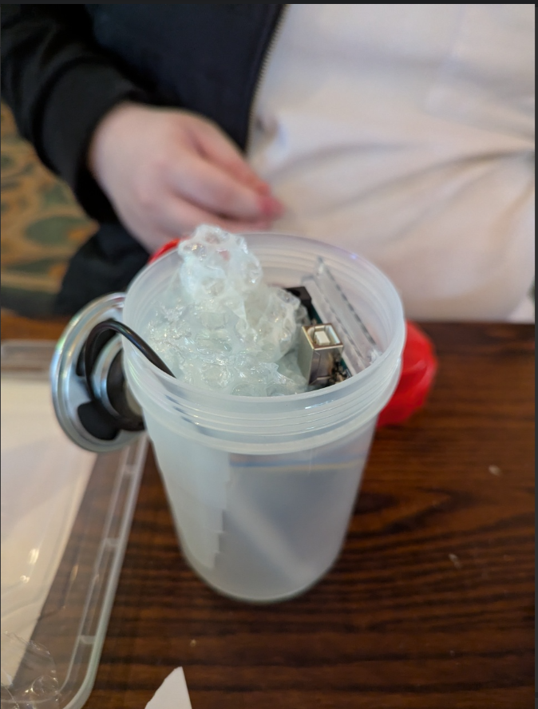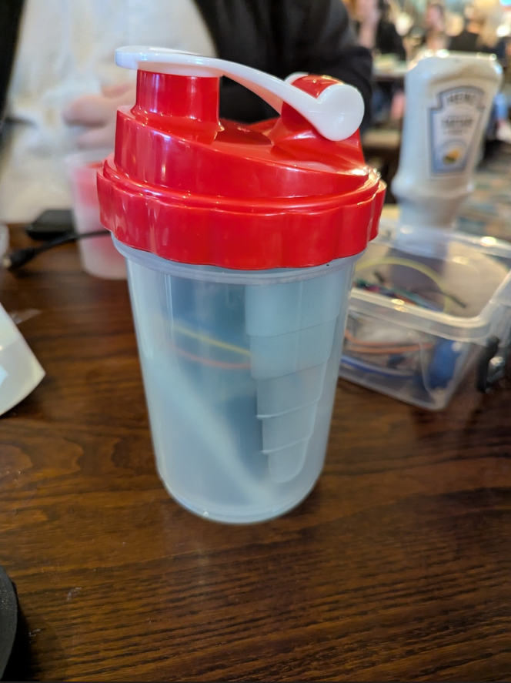

We got the Arduino, and all the other components connected and attached with electrical tape, put it into the shaker bottle with some bubble wrap as padding to keep it in place and not shake around in the shaker and get damaged.

We put the speaker at the top of it all facing upwards for the best sound.

[](https://bathspaonline-my.sharepoint.com/:v:/r/personal/fred_burdekin22_bathspa_ac_uk/Documents/Tangible%20games/Arduino%20Game%20Stuff/Documentation%20Pics/Final%20Arduino.mov?csf=1&web=1&nav=eyJyZWZlcnJhbEluZm8iOnsicmVmZXJyYWxBcHAiOiJPbmVEcml2ZUZvckJ1c2luZXNzIiwicmVmZXJyYWxBcHBQbGF0Zm9ybSI6IldlYiIsInJlZmVycmFsTW9kZSI6InZpZXciLCJyZWZlcnJhbFZpZXciOiJNeUZpbGVzTGlua0NvcHkifX0&e=8Bxqu1)

***VIDEO***

Final Arduino.mov

This video shows our final version and builds of our tangible game with all the components put together inside of the shaker bottle with just the power bank outside supplying power to the devices.

The video shows off the whole game and how it would be interacted with by the player. The device only counts a shake if done correctly and doesn't count it or beep when passing the device across to other players, only when shaken up and down.

The device is also very accurate and responsive; you never get a beep to say that the device has been shaken when you don't feel like it should have counted.

The feedback to the player is also very clear, clearly beeping to indicate that it has been shaken, beeping twice to indicate that it is close to exploding and beeping a lot to tell the players that the bottle has exploded and the round is over. There is always feedback being given to the player and the device always feels very responsive to use.